Lab – NETCONF w/Python: Device Configuration

1. Objectives

Part 1: Retrieve the IOS XE VMs’ existing running configuration

Part 2: Update the device’s configuration

1. Background / Scenario

In this lab, you will learn how to use the NETCONF ncclient to retrieve the device’s configuration, update and create new interface configuration. You will also learn why the transactional support of NETCONF is important for getting consistent network changes.

1. Required Resources

* Access to a router with the IOS XE operating system version 16.6 or higher
* Python 3.x environment

1. Retrieve the IOS XE VMs’ existing running configuration

In this part, you will use the ncclient module to retrieve the device’s running configuration. The data are returned back in XML form that in the following steps is being transformed into more human readable format.

* + 1. Use ncclient to retrieve the device’s running configuration.

The ncclient module provides a “manager” class with “connect()” function to setup the remote NETCONF connection. After a successful connection, the returned object represents the NETCONF connection to the remote device.

* + - 1. In Python IDLE, create a new Python script file:

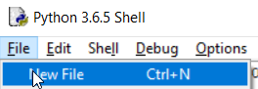

* + - 1. In the new Python script file editor, import the “manager” class from the ncclient module:  
           
         **from** ncclient **import** manager

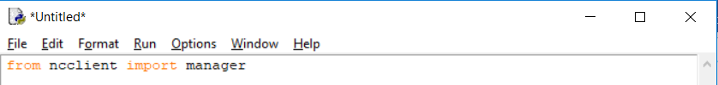

* + - 1. Setup an m connection object using the manager.connect() function to the IOS XE device.

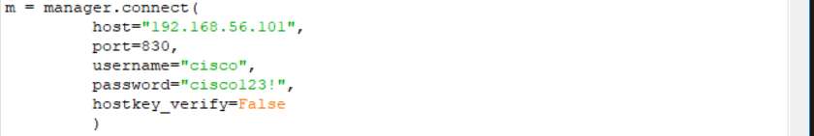

The parameters of the manager.connect() function are:

* host – the address (host or IP) of the remote device (adjust the IP address to match the router’s current address)
* port – the remote port of the ssh service
* username – remote ssh username (in this lab “cisco” for that was setup in the IOS XE VM)
* password – remote ssh password (in this lab “cisco123!” for that was setup in the IOS XE VM)
* hostkey_verify – whether to verify the ssh fingerprint (in lab it is safe to set to False, in production environments you should always verify the ssh fingerprints)
  + - 1. After a successful NETCONF connection, using the “get_config()” function of the “m” NETCONF session object retrieve and print the device’s running configuration. The get_config() function expects a “source” string parameter that defines the source NETCONF data-store.

netconf_reply = m.get_config(source="running")

**print**(netconf_reply)

* + - 1. Execute the Python script and explore the output:

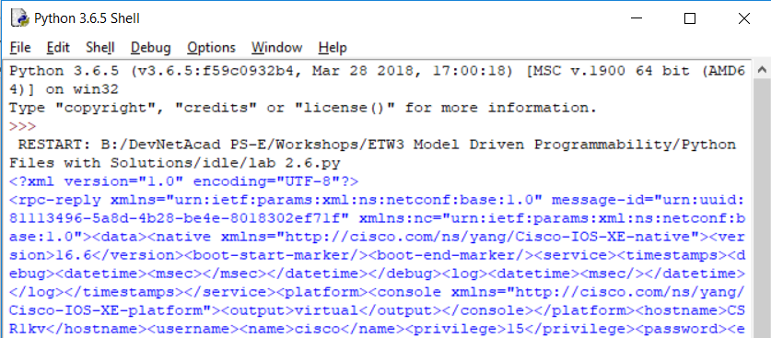

...

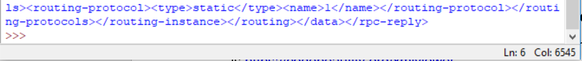

* + 1. Use CodeBeautfiy.com to evaluate the response

Code Beautify maintains a website for viewing code in a more human readable format. The XML viewer URL is <https://codebeautify.org/xmlviewer>

* + - 1. Copy the XML from IDLE to XML Viewer.
      2. Click **Tree View** or **Beautify / Format** to render the raw XML output into a more human readable format.

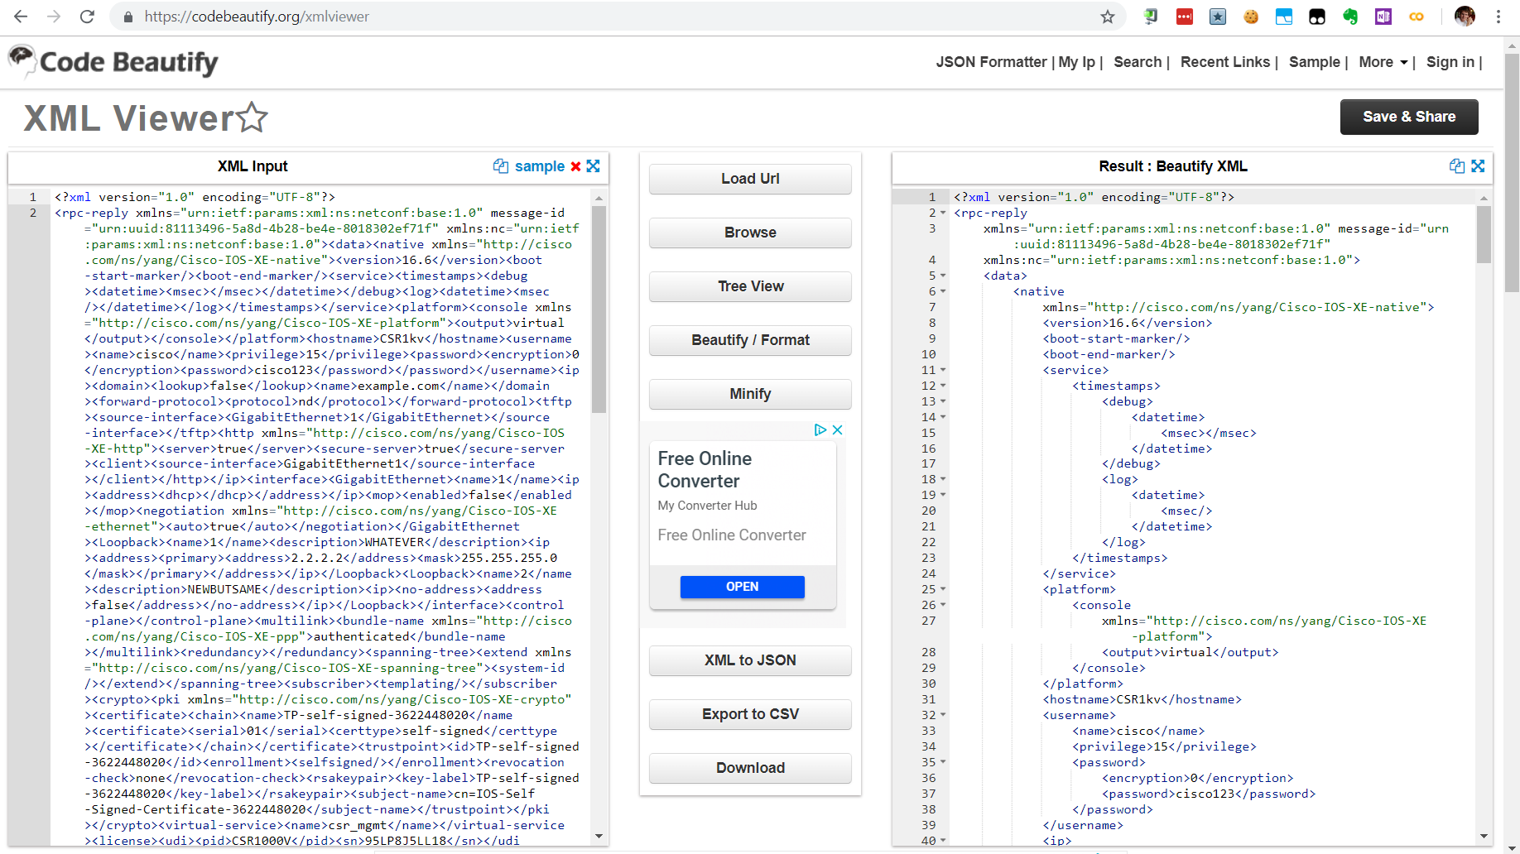

* + - 1. To simplify the view, close the XML elements that are under the rpc-reply/data structure:

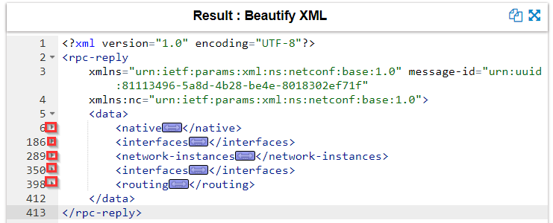

* + - 1. Note that the rpc-reply/data/native element when opened, it contains an attribute xmlns that points to “Cisco-IOS-XE-native” YANG model. That means this part of the configuration is Cisco Native for IOS XE.

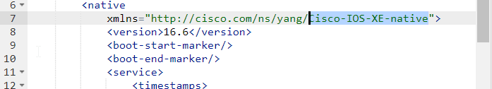

* + - 1. Also note that there are two “interfaces” elements – one with xmlns pointing to “http://openconfig.net/yang/interfaces” YANG model, while the other pointing to “ietf-interfaces” YANG model.

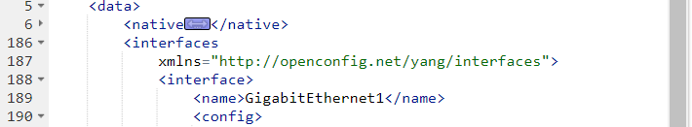

…

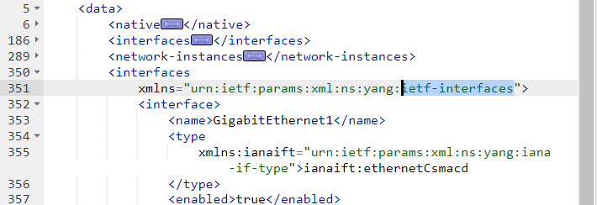

Both are used to describe the configuration of the interfaces, with a difference that the openconfig.net YANG model does support sub-interfaces, while the ietf-interfaces YANG model does not.

* + 1. Use toprettyxml() function to prettify the output.
       1. Python has built in support to work with XML files. The “xml.dom.minidom” module can be used to prettify the output with the toprettyxml() function.
       2. Import the “xml.dom.minidom” module:

**import** xml.dom.minidom

* + - 1. Replace the simple print function “print( netconf_reply )” with a version that prints prettified XML output:

**print**( xml.dom.minidom.parseString(netconf_reply.xml).toprettyxml() )

* + - 1. Execute the updated Python script and explore the output.
    1. Use filters to retrieve a configuration defined by a specific YANG model
       1. NETCONF has support to return only data that are defined in a filter element.
       2. Create the following netconf_filter variable that contains an XML NETCONF filter element to only retrieve data defined by the Cisco IOS XE Native YANG model:

netconf_filter = """

<filter>

    <native xmlns="http://cisco.com/ns/yang/Cisco-IOS-XE-native" />

</filter>

"""

* + - 1. Include the netconf_filter variable in the get_config() call using the “filter” parameter:

netconf_reply = m.get_config(source="running", filter=netconf_filter)

**print**(xml.dom.minidom.parseString(netconf_reply.xml).toprettyxml())

* + - 1. Execute the updated Python script and explore the output:

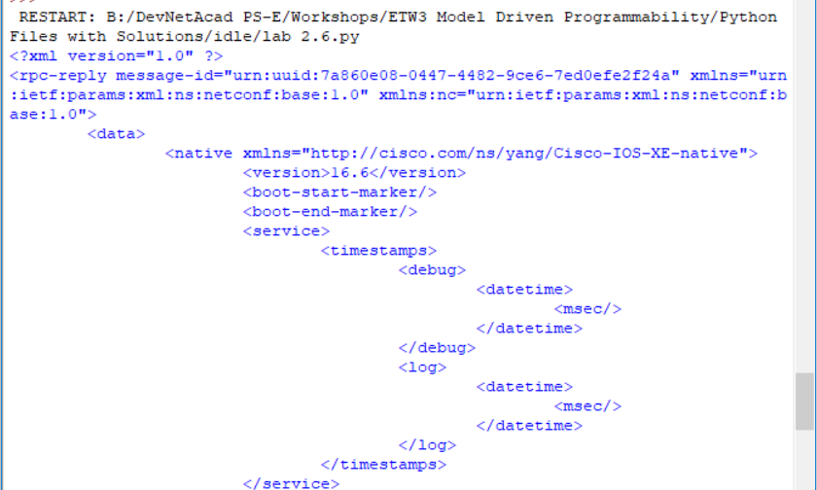

…

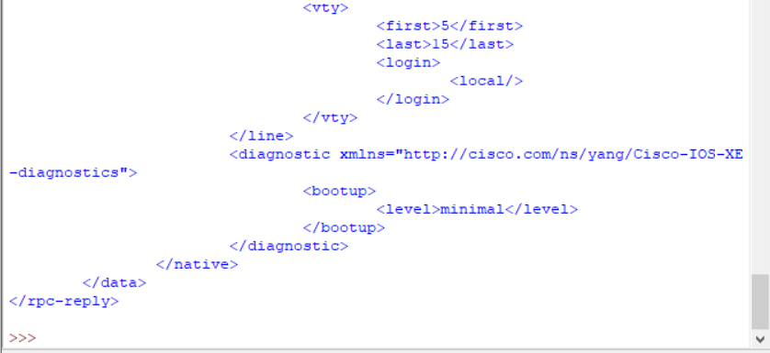

1. Update the device’s configuration
   * 1. Create a new Python script file
        1. In IDLE create a new Python script file
        2. Import the required modules and setup the NETCONF session:

**from** ncclient **import** manager

**import** xml.dom.minidom

m = manager.connect(

host="192.168.56.101",

port=830,

username="cisco",

password="cisco123!",

hostkey_verify=False

)

* + 1. Change the hostname
       1. In order to update an existing setting in the configuration, you can extract the setting location from the configuration retrieved in Step 1:

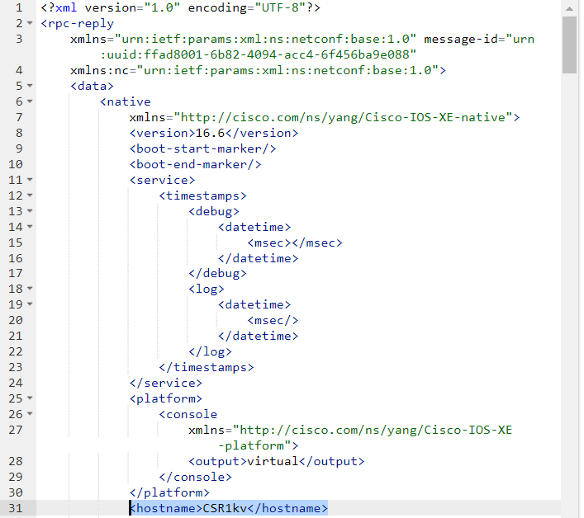

* + - 1. The configuration update is always enclosed in a “config” XML element that includes a tree of XML elements that require update.
      2. Create a netconf_data variable that holds a configuration update for the hostname element as defined in the Cisco IOS XE Native YANG Model:

netconf_data = """

<config>

<native xmlns="http://cisco.com/ns/yang/Cisco-IOS-XE-native">

<hostname>**NEWHOSTNAME**</hostname>

</native>

</config>

"""

* + - 1. Edit the existing device configuration with the “edit_config()” function of the “m” NETCONF session object. The edit_config() function expects two parameters:
* target – the target netconf data-store to be updated
* config – the configuration update

The edit_config() function returns an XML object containing information about the change success. After editing the configuration, print the returned value:

netconf_reply = m.edit_config(target="running", config=netconf_data)

print(xml.dom.minidom.parseString(netconf_reply.xml).toprettyxml())

* + - 1. Before executing the new Python script, check the current hostname by connecting to the console of the IOS XE VM.
      2. Execute the Python script and explore the output:

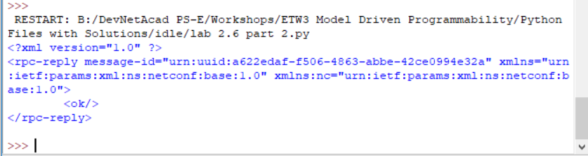

* + - 1. After executing the Python script, if the reply contained the <ok/> element, verify whether current hostname has been changed by connecting to the console of the IOS XE VM.
    1. Create a loopback interface
       1. Update the netconf_data variable to hold a configuration update that creates a new loopback **100** interface with the IP address **100.100.100.100**/24:

netconf_data = """

<config>

<native xmlns="http://cisco.com/ns/yang/Cisco-IOS-XE-native">

<interface>

<Loopback>

<name>**100**</name>

<description>TEST1</description>

<ip>

<address>

<primary>

<address>**100.100.100.100**</address>

<mask>255.255.255.0</mask>

</primary>

</address>

</ip>

</Loopback>

</interface>

</native>

</config>

"""

* + - 1. Add the new loopback 100 interface by editing the existing device configuration using the “edit_config()” function:

netconf_reply = m.edit_config(target="running", config=netconf_data)

print(xml.dom.minidom.parseString(netconf_reply.xml).toprettyxml())

* + - 1. Before executing the updated Python script, check using “show ip int brief” and “show int desc” the existing loopback interface by connecting to the console of the IOS XE VM. Take a screenshot of the result.
      2. Execute the Python script and explore the output:



* + - 1. After executing the Python script, if the reply contained the <ok/> element, verify whether current loopback interfaces have changed by connecting to the console of the IOS XE VM. Check using “show ip int brief” command. Take a screenshot of the result.
    1. Attempt to create a new loopback interface with a conflicting IP address
       1. Update the netconf_data variable to hold a configuration update that creates a new loopback **111** interface with the same IP address as on loopback 100: 100.100.100.100/32:

netconf_data = """

<config>

<native xmlns="http://cisco.com/ns/yang/Cisco-IOS-XE-native">

<interface>

<Loopback>

<name>**111**</name>

<description>TEST1</description>

<ip>

<address>

<primary>

<address>**100.100.100.100**</address>

<mask>255.255.255.0</mask>

</primary>

</address>

</ip>

</Loopback>

</interface>

</native>

</config>

"""

* + - 1. Attempt to add the new loopback 111 interface by editing the existing device configuration using the “edit_config()” function:

netconf_reply = m.edit_config(target="running", config=netconf_data)

print(xml.dom.minidom.parseString(netconf_reply.xml).toprettyxml())

* + - 1. Before executing the updated Python script, check using “show ip int brief” and “show int desc” the existing loopback interface by connecting to the console of the IOS XE VM. Take a screenshot of the result.
      2. Execute the Python script and explore the output:

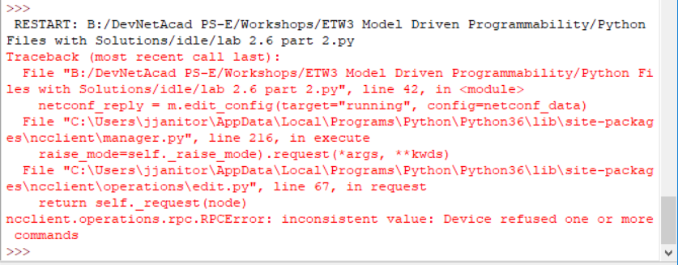

The device has refused one or more configuration settings. With NETCONF, thanks to the transactional behavior, no partial configuration change has been applied but the whole transaction was canceled.

* + - 1. After executing the Python script, verify that no configuration changes, not even partial have been applied: Check using “show ip int brief” and “show int desc” Take a screenshot of your result.